BFU: Communism and the Masses
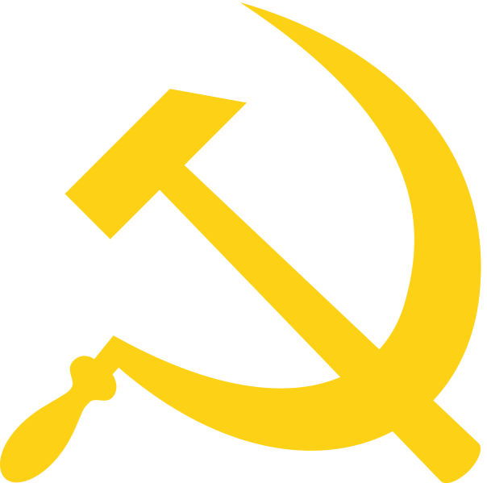
Misconceptions:

Life got way better for everyone during the Industrial Revolution.

People discovered farming 12,000 years ago. Farming made it possible for people to stop hunting and stay in one place. They developed cities and governments and religions and culture. Sounds great? Recent studies show that actually, no, for most people, it was a bad idea. People died earlier. They didn’t get as good nutrition as before. Diseases got worse because everyone lived close together.
Life got way better for some people: the kings, the leaders, the priests, and the powerful families. But not for everyone; for most people it got worse. This is when we start talking about the “social hierarchy.” Some people are on top; most people are on the bottom.
The same thing happens in the Industrial Revolution. We start talking about classes.
Karl Marx is a man from Germany in the 1800s. He is famous as the founder of Communism. He writes a book called Das Capital that describes capitalism. He is not happy with capitalism; he is critical of capitalism.

Rewrite
1. Karl Marx is the founder of Communism
2. Karl Marx loved Critical capitalism.

Karl Marx writes about classes. He writes about the “bourgeoisie” who are on top. They own everything and do little work. The bourgeoisie are what we call the upper class.

He writes about the Proletariat. They are the workers. They do all of the work but they own nothing. They get little money and are exploited.
Karl Marx creates the ideas of Communism. It is also called Marxism.
Complete
1. Who is on the top of the social classes according to Marx?
Bourgeoisie are on the upper class.
2. Karl Marx created the ideas of what?
Karl Marx create the ideas of Communism

Communism becomes the opposite of Capitalism. After World War II, the big struggle is between Capitalism and Communism. This is the Cold War between the USA and the USSR. The USA is capitalist; the USSR is Communist.

Rewrite

1. The USA is capitalist

2. The USSR is communist

Complete
1. The major struggle is between Capitalism and Communism.

The ideas of Communism are:
- Capitalism causes injustice (it is not fair)
- The Proletariat does all of the work and gets nothing
- The Bourgeoisie does none of the work and gets everything
- The Proletariat will realize that they are being oppressed (taken advantage of)
- There will be a revolution
- The Proletariat will take over the factories and kill the Bourgeoisie
- The Proletariat will redistribute the wealth equally
In other words, the workers will take over the factories. But when they are in control, they will share the profits. They will share instead of the owner getting everything.
But why were the Proletariat so angry? Life is unfair, right… at least they had jobs!
Rewrite
1. Capitalism causes injustice.
2. The Bourgeoisie are rich people and owners.
3. The Proletariat are the poor people and workers.
4. The Proletariat will redistribute the wealth equally.
Misconceptions:

Life got way better for everyone during the Industrial Revolution.

The working conditions during the Industrial Revolution are bad. They make working 3 jobs at McDonalds, Walmart, and Petsmart seem easy.

These are the problems of the Industrial Revolution:

-bad working conditions in dangerous factories

-child labor: kids working in factories instead of studying

-abusive owners: factory owners did whatever they wanted to their workers

-pollution and dirty cities

-the end of traditional “cottage” industries

-enclosure and the loss of traditional farmland
Complete
What are the problems of the industrial revolution?
1. Bad working conditions in dangerous factories
2. Child labor: kids working in factories instead of studying
3. Abusive owners: factory owners did whatever they wanted to their workers
4. Pollution and dirty cities
5. The end of traditional “cottage” industries
6. Enclosure and the loss of traditional farmland

Working conditions are bad: There aren’t safety regulations; people die at work and nothing happens. Bosses do whatever they want. Salaries are low. Children work. People work 15 hour days, 6 days a week. There are lots of stories about working conditions and we aren’t going to focus on them. Pollution is terrible. Many people in England die of a disease caused by lack of sunlight because they never go outside. They work in a factory all day. When they go outside, they can’t see the sun because of all the black smoke. There are no vacations. There is no education. People hate living in the city but they can’t leave because there’s no work back home on the farm.

Summarize
How are working “bad” conditions?

Work is sometimes bad because in many places they don’t provide life insurance, and if anything happens to any employees he will have to pay all hospital charges of their own salary . In some places the manager are very bad and mistreat people, especially people who do not have documentation.
Cottage Industries:

Traditional society ends: Before industrialization, people shared a lot of things. They shared land. There was always common land for people to farm on. Industrialization causes inflation: things get expensive. Land gets expensive. So nobody shares land anymore. This is called the Enclosure Movement. Landowners put fences around their land. They kick the poor people off. They move to the city. It’s the same with cottage industries: People used to make their own clothes and tools. This is what a cottage industry is: A little business like making horse shoes or clothes or whatever. Not anymore. These industries end. Factories are it. Either work in a factory or die.

Summarize
1. How do traditional industries disappear?

Landowners put fences around their land. They kick the poor people off. They move to the city. It’s the same with cottage industries: People used to make their own clothes and tools. This is what a cottage industry is: A little business like making horse shoes or clothes or whatever. Not anymore. These industries end. Factories are it. Either work in a factory or die.
A lot of this should sound familiar, especially if you are an immigrant who left his country because there was no work.

Let’s think about El Salvador. Before industrialization, there was always work.

Anecdote: Frijol the Farmer

Let’s imagine the story of Frijol the Farmer.

Frijol is born in a small town in 1950s in San Miguel. His family works for the local big boss, Elias. They are farmers. As long as they work on Elias’ fields, they can have a little garden for themselves. They survive and are pretty independent. They share with other people in the town if there is bad harvest. People help each other. There is work.

Then one day, a group of Americans come. They work for a guy named Ray Krock. They buy all the land in Frijol’s town. They put up a big fence. No more sharing the land! It’s too valuable! These Americans bring a bunch of cows over. They
make a beef-processing factory. Cows eat corn; cows get fat; cows go to the factory. In the factory, the cows are killed and ground up into little beef patties.

Frijol looks for a job at the factory. They reject him! Sorry, there’s no work. We already hired 50 workers. We don’t need more. Go back to whatever you were doing. Frijol can’t go back to what he was doing. He doesn’t have land. So he goes North to the USA. He gets a job working in a place that, by the way, is owned by a guy named Ray Krock. It’s called McDonalds, and their specialty is little patties of beef made in Central America.

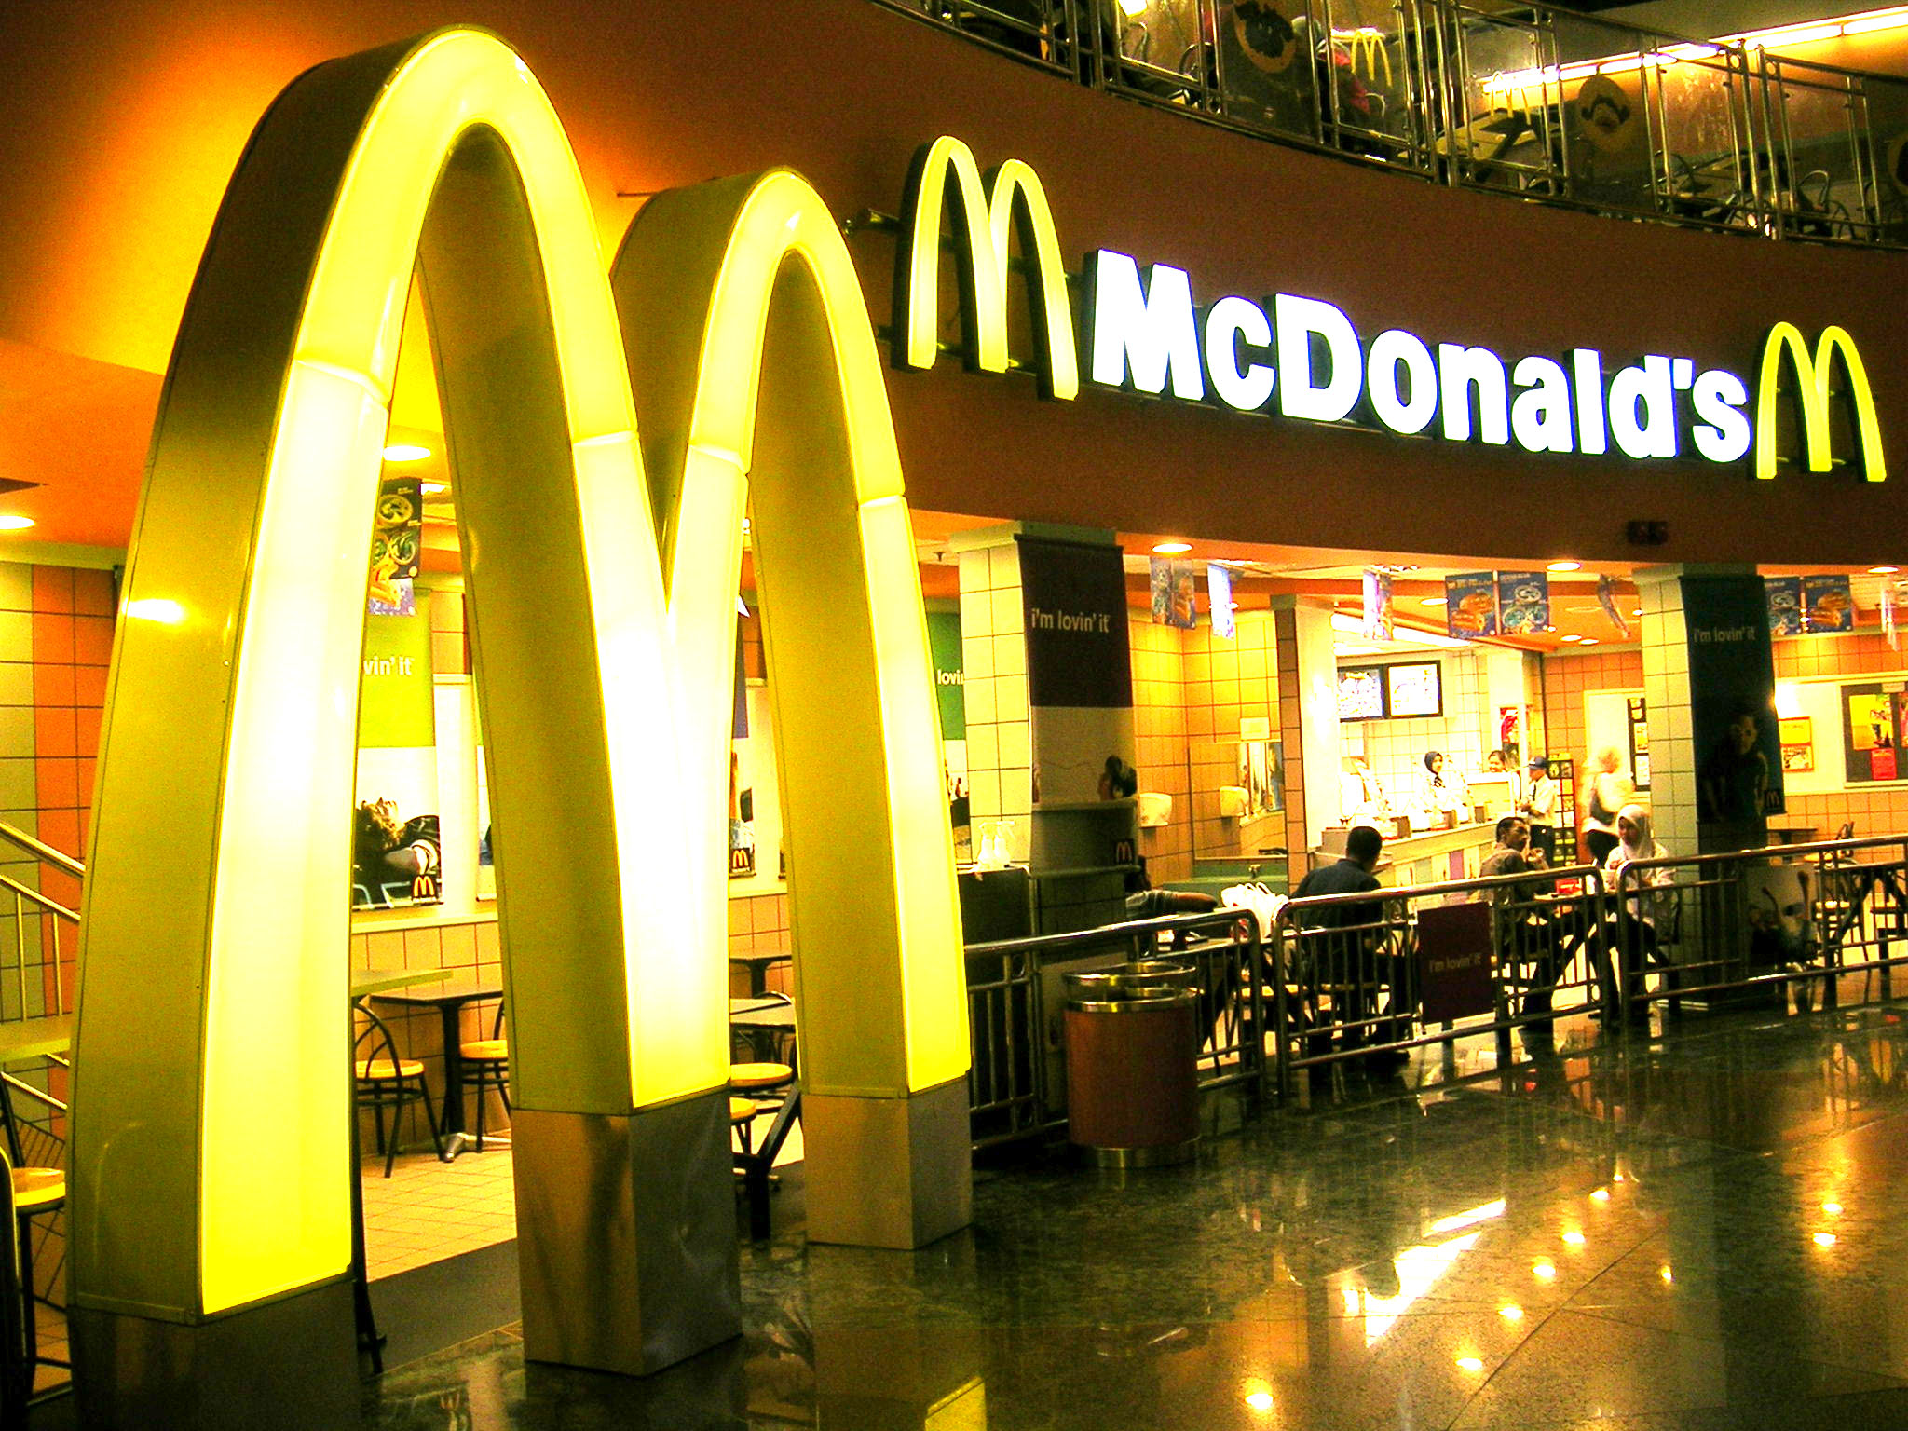
Summarize
1. Summarize the story of Frijol the Farmer--

Frijol is born in a small town in 1950s in San Miguel. His family works for the local big boss, Elias. They survive and are pretty independent. They share with other people in the town if there is bad harvest. Then one day, a group of Americans come. They work for a guy named Ray Krock. They buy all the land in Frijol’s town. Frijol looks for a job at the factory. He gets a job working in a place that, by the way, is owned by a guy named Ray Krock. It’s called McDonalds, and their specialty is little patties of beef made in Central America.

Misconceptions:

Workers in the 1800s did nothing about their bad conditions!

If you a worker in the 1800s, what would you do? What is the answer for you? Many workers are just happy to have a job. But many feel they should do something.

Some follow the ideas of Marx. They want a revolution. They want to kill the factory owners and take over.

But others want to negotiate. They want to make a deal with the factory owners for better conditions. One man alone can’t say much; but a whole bunch of men can… They form unions.

Labor unions are groups of workers… like 500 workers. They make demands like more money or safer work or Sundays free. They make demands and if they don’t get what they want, they have strikes.

Strikes are when workers just stop working. Imagine if you have a bad teacher, and everyone in the class just puts their head down. Just heads down, everyone, 90 minutes. This causes a big problem. That is a strike. That is what Labor Unions do. They have some successes but not a lot.

What really shakes things up—what really changes things is when the Communists get their revolution.
They get it in a the strangest country, though…

Complete
- Who are fighting against the economic dominance of the bourgeoisie?
Others people want to negotiate. They want to make a deal with the factory owners for better conditions.
- What are bourgeoisie?
Is the middle class, typically with reference to its perceived materialistic values or conventional attitudes.

Misconceptions:

The USSR is the Communist Revolution that everyone wanted and expected.

Karl Marx expected that England or Germany would have a Communist Revolution. Communism should have happened in an industrialized country. But it didn’t. It happened in Russia.

Complete
- Where did Karl Marx expect revolution?
England or Germany
- Where did Revolution occur?
It happened in Russia.

Russia in 1917 is a country of farmers. But they have a Communist Revolution. And it succeeds. And they become the USSR—the first and strongest Communist country in the world. The wannabe Workers’ Paradise. The revolution occurs in Russia, even though it shouldn’t.

Rewrite
1. Russia is a country of farmers in 1917.
2. The Communist Revolution occurs in Russia.
3. The Communist Revolution should have occurred in England.

How does this happen? Russia is ruled by kings. The kings are called Czars. The Czars are from the same family as the kings of England and Germany. They are the Romanovs. They believe in Divine Right monarchy, even though nobody else does. They still think they are the FATHERS of the farmers.

True/False
1. Czars believe in divine right. True
2. Russia is ruled by Czars. True
3. Russia is ruled by democracy. False

But Russia has big problems. First of all, yeah, it’s big. It’s a huge country with a massive population. Most of the population is poor. They are given their “freedom” years before. But in the early 1900s, they want to know what happens next. When do they get something.

Russia also shows weakness. Again and again, they lose wars. The biggest thing is that they lose to the Japanese. No European country loses to non-Europeans; and the Russians lose to Japan. People blame the king.

Rewrite

1.. Russia has big problems.

2. Russia lose the war against Japan.

The king is useless. We’ll call him Czar because that’s what people called him. His name is Czar Nicholas II and he has no idea how much people hate him. Czar Nicholas II believes that people think God supports him. He goes into World War I thinking that people are happy to die for him. He is wrong!

Czar Nicholas II is a weak leader; World War I is a horrible war. There are major revolts. There are many groups who want to take over. The biggest group is republicans. They support Enlightenment ideas of voting and democracy.
They are called the Whites. They lose. The Whites lose to the Reds. Who are the Reds?

Complete
1. Who is the leader of Russia during WWI?
Czar Nicholas II
2. What do the people think of Czar Nicolas?
People hate Czar Nicholas
3. The Republicans are represented by what color?
White
- Who do you think the Reds are?
The Reds are Communists
The Reds are Communists. The Reds support the ideas of Karl Marx. They want to end private property and make an equal society. Their leader is Vladimir Lenin.
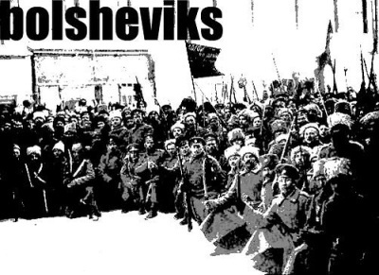
The Reds are called Communists. They are also called Bolsheviks, which means the minority. The Bolsheviks slowly get more and more powerful. Their leader is great; Vladimir Lenin wins the important battles.

Rewrite
1. The Reds are Communism.
2. The leader of the Reds is Vladimir Lenin.
3. The Reds are also called the Bolsheviks.

Soon, they depose the Czar and kill the Royal family. All of the Royals die. There is a new government. It is a Communist government. It is the USSR.

Complete
1. What happens to the Czar?
They depose the Czar
2.What is the name of the new country?
USSR
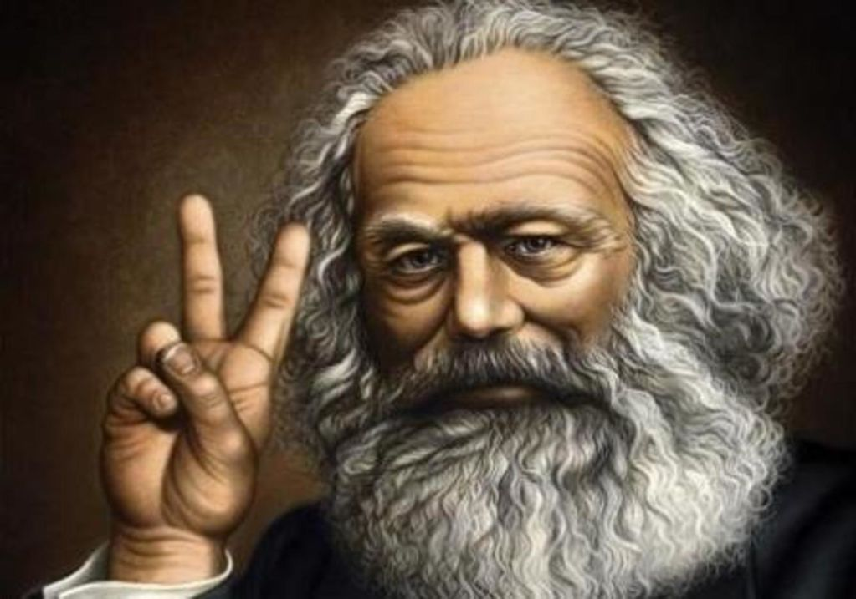

Communism is very strict. There are strict rules about how to conduct yourself. Karl Marx did not believe in war. He believed that war was only to the advantage of Capitalists. So, when the Communists win, they make peace.

The revolution of the Communists is called the Russian Revolution. It happens in 1917. In 1917. the new country USSR wins the war. Next, Lenin has to figure out how to make a Communist country.

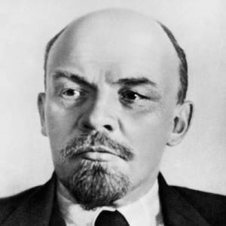Le L

USSR is complicated. It can’t be Communist right away because there are no factories. Communism depends on factories; the workers take over the factories and make an equal society.
Rewrite
1. The new country is Communist.
2. The new country wants to peace WW1.
3. The name of the new country is USSR
4. The new country is capitalist.
5. The USSR can’t be 100 percent Communist because there are no factories.

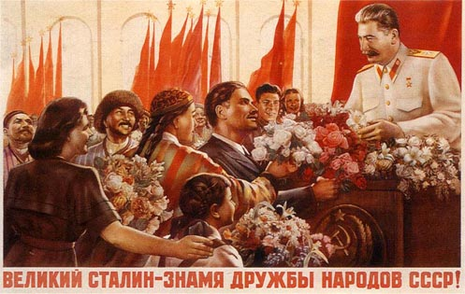

Lenin starts by taking over everyone’s property. But there is a problem. The rich people leave and Russia becomes poor. So he makes some reforms. They are capitalist reforms. This is the New Economic Policy (NEP), which moves away from Communism.

USSR is poor. Millions of people die of starvation. The leaders can’t decide on whether to be Communist or Capitalist. It’s a poor country.

Complete
1. The first leader of USSR is called Lenin.
2. Lenin starts his plan by taking over everyone’s property.
3. The plan of Lenin is called NEP.

Josef Stalin takes over after Lenin dies. He is Communist and Totalitarian. He focuses on industrialization, at the cost of everything else. Stalin does whatever he wants. He forces people to move from place to place. He forces farmers to melt their plows into steel so they can make industrial products. Stalin is a dictator. The idea of Communism—or the workers’ paradise—becomes confused.

Summarize
1. How is Stalin different?

Josef Stalin is different because he is Communist and Totalitarian. He focuses on industrialization Stalin does whatever he wants, he forces people to move from place to place, he forces the farmers to melt their plows into steel so they can make industrial products. Stalin is a dictator.

So, what of Communism? What of the USSR? We look at this country now and we call it Communist. We call it a country that wanted to make everyone equal. But that’s probably not true. USSR showed the growth of Russian nationalism. USSR was never ready for a Communist revolution.

Communism requires Industrialization. Russia was all farmers. Communism requires equality. Russia was a dictatorship. First, Lenin. Then, Stalin. And till the end—one leader over all.
So, what countries followed Marx and became workers’ paradises? Where did Labor Unions strike back against the owners?

Labor Unions probably had the most success in the USA and other capitalist countries. There was a time in the USA when factory workers are middle class. They live in Detroit, work fflives. This is most likely because wages get high enough because profits are good and prices are low. We’ll probably never know. But Communism failed. It failed from the beginning. The Workers’ Paradise never happened because the Revolution happened in the wrong place.

Complete
1. What are labor unions?
Labor unions are groups of workers. They make demands like more money or safer work or Sundays free. They make demands and if they don’t get what they want, they have strikes.

Summary True/False

1. Communism was a success False

2. Communism created a Worker’s Paradise False

3. Russia was a good place for the Communist Revolution False

