Profile: Honduras
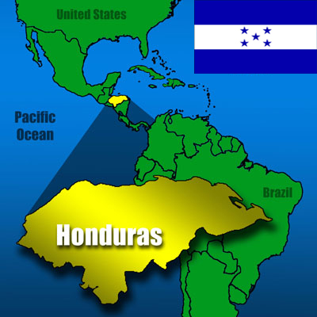

This is a profile of Honduras. It is the poorest country in the region of Central America. The GDP of Honduras is approximately 18.55 Billion dollars per year.

Exports | %
Clothing | 11
Coffee | 10
Tabaco | 2.3
Stamps | 6.2
Fiber Cables | 4.6

Regional Economies
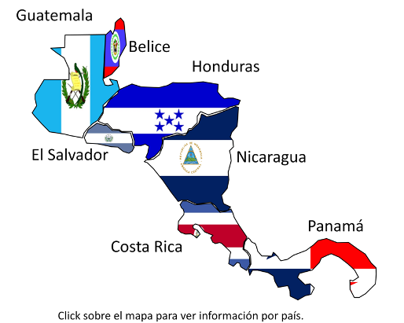
Country | GDP | Main Exports
Guatemala | 78.681 billion | Coffee, Raw Sugar Cane, Clothing, Bananas
El Salvador | 52.666 billion | Clothing, Sugar Cane, Packing of Goods, Coffee, Electrical Capacitors
Nicaragua | 31.721 billion | Coffee, Bovine Meat, Cheese and Curd, Fresh Chilled
Honduras | 18.55 billion | Clothing, Coffee, Tabaco, Stamps, Fiber Cables

The regional economy is agriculture. The region is dominated by Guatemala. However, the other countries in the region of Centro America are strong. Honduras is behind the other countries in exports and GDP.

